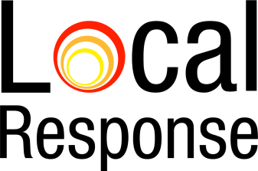

What information can I share? Do I need to ask permission?
We respect private information and use information provided to us to create maps and verify data. The information that is displayed, in accordance with the Information Privacy Principle 11 (f) complies with the requirements outlined and the following apply—
(i) the disclosure is necessary for research, or the compilation or analysis of statistics, in the public interest;
(ii) the disclosure does not involve the publication of all or any of the personal information in a form that identifies the individual;
(iii) it is not practicable to obtain the express or implied agreement of the individual before the disclosure;
(iv) the agency is satisfied on reasonable grounds that the relevant entity will not disclose the personal information to another entity.

The information provided is managed by us and is not provided to any other entity. The maps created may be used and provided to the Community Sector.

